**LAB EXPERIMENT : 6**

**Install & Configure Visual Studio Code as an IDE, setup an environment for React by downloading Node.js and install React framework along with its packages. Understand the folder structure used by React and develop a “Hello World Application”.**

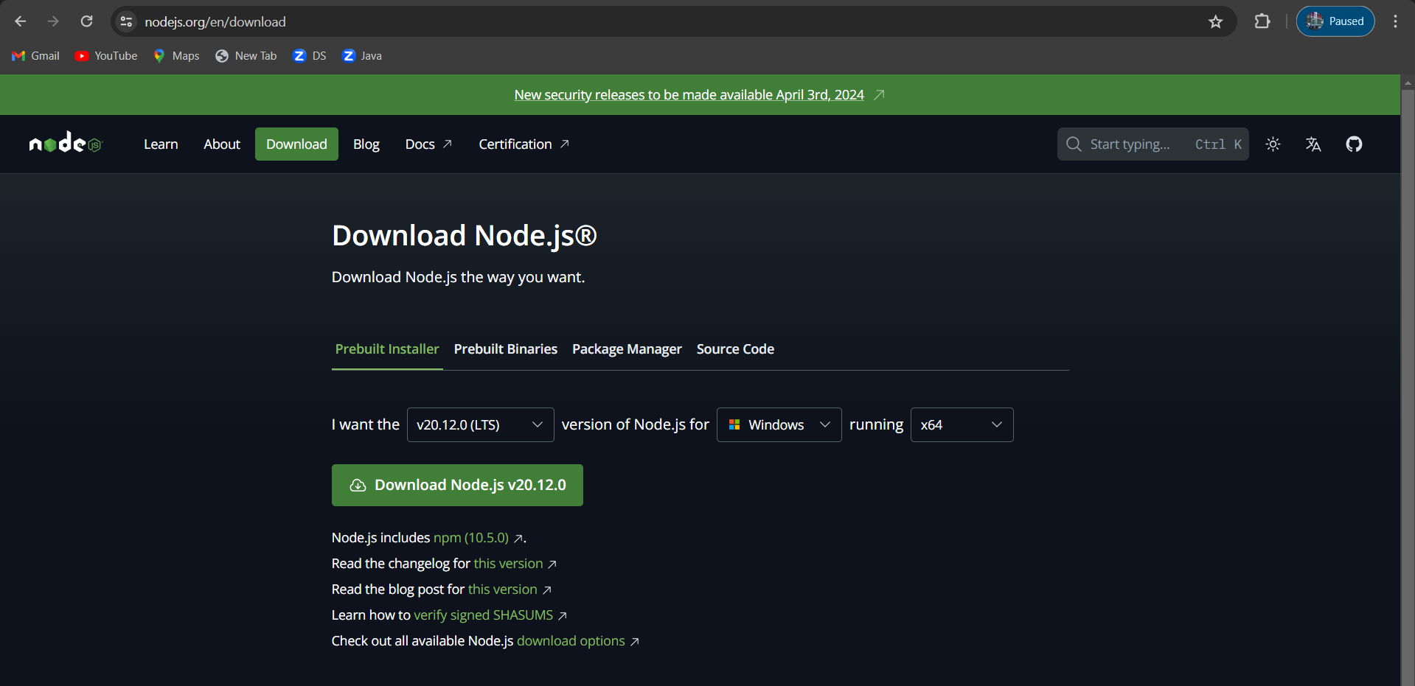

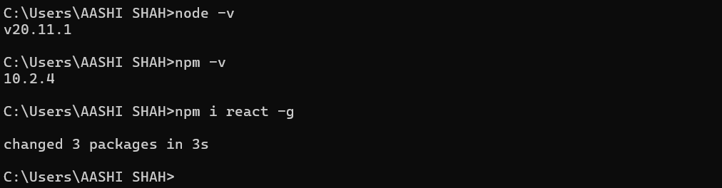

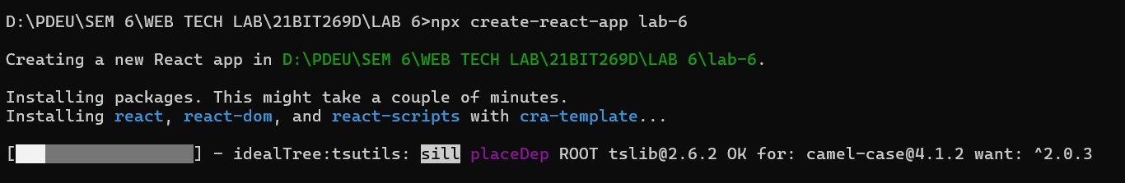

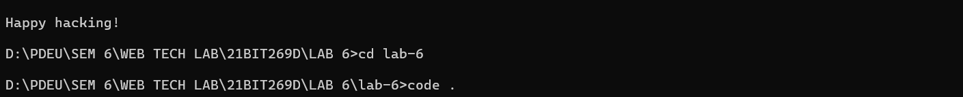

The code presents a basic React component using JSX, rendering "Hello World" within a element with specified inline styles.

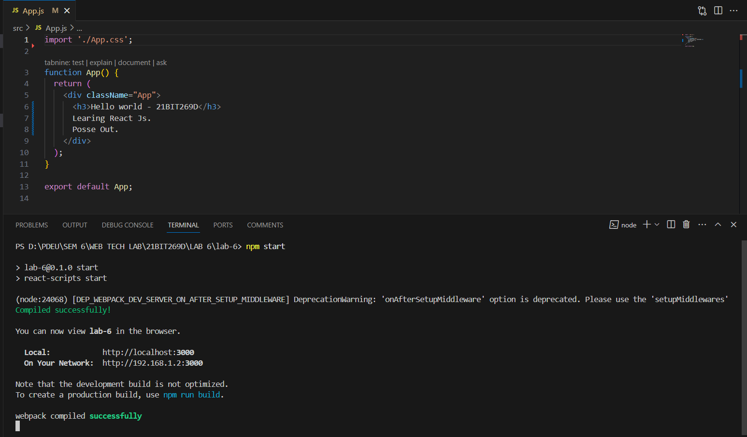

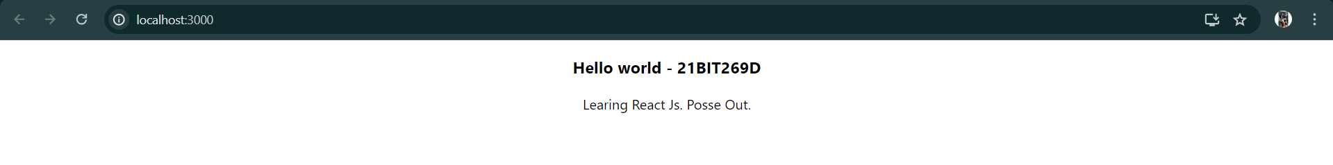

**Discussions:**

In this experiment, downloaded Node.js for React, configured the React framework using npm, understood React's folder structure, and developed a simple "Hello World Application" using React components and JSX syntax.